Caythorpe Pre- School

Registered Charity No. 1211490

Ofsted Registration No. 2879091

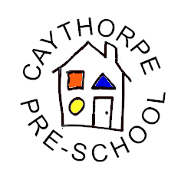

Complaints Procedure

If there is anything about our Pre-school that you wish to complain about, please either speak or write to:

Deborah Pinfold Pre-school Leader 07356 074749

Georgina Donald Committee Chair 07356 074749

If you are still not happy after speaking to the above, please feel free to contact OFSTED. You can do this by visiting www.ofsted.gov.uk and following the instructions on the screen.

If you do not have access to the internet you can telephone 0300 123 4666 or write to:

